Mason Library – Digitization Lab - Scanning Tutorial

This living guide should also be used as a check list and should be added too when needed.

The Mason Library has 2 scanners in the Digitization Lab. Both scanners are supported through contract by the Digital Library Systems Group (**DLSG**) at Image-Access. DLSG also provided the Mason Library with the 2 **KIC** scanners and the **Bookeye 3** scanner in the Interlibrary Loan office.

The **Bookeye 3** scanner is a very large book scanner with adjustable beds and a glass screen. It can scan up to 25”x20”, 600x400 dots-per-inch (dpi) in 24-bit color, and has Ethernet connectivity allowing for high-speed scan transfers to the workstation. Take a look at the Bookeye3 below.

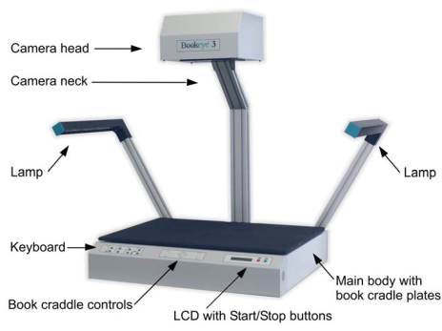

Turn on the scanner(s), on the **Bookeye3** press the green **Start** button on the front of the scanner. ***NOTE:*** If the scanner has been powered down the power switch is located on the back of the scanner.



* Raise the glass cover and put a book on the platform. Close the glass cover and use the **UP arrow buttons** on the **Bookeye3** to raise the platform until the glass is **flat** and **parallel** to the floor. 

To Operate both plates at the same time…  
  
This key moves both plates upwards exactly in synchronization.

This key moves both plates down exactly in synchronization.

Once a book has been balanced on the two book cradles, the compensator keys are used to compensate between the two sides. That means the surface of the book is at the same height on both sides. The right compensator key operates identically on the right cradle.



The left compensator key lifts the left cradle and lowers the right cradle in synchronization.



The right compensator key lifts the right cradle and lowers the left cradle in synchronization.

The lab’s **WideTEK25** is a large flat-bed scanner capable of scanning 18.5”x25” documents at 300 dpi. It is also has Ethernet connectivity and uses Infrared and Ultra-Violet free scanning using “no-warm-up” LED lamps. Here is a photograph of the **WideTEK25.**

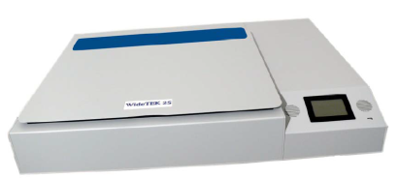

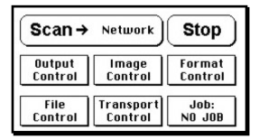

On the **WideTEK25,** press on the touch-screen on the front of the scanner to wake it up.   
  
**NOTE:** If the scanner has been powered down the power switch is located on the back of the scanner.

When using the **WideTEK25** ensure that the document is lined up with the markers on the scanner, flat, and **facedown**.

The software used currently for scanning is called **Opus FreeFlow**. FreeFlow was created specifically for libraries that intend to digitize collections of books and other objects. This tutorial will focus on the software application and how to interact between the software and the physical scanners.

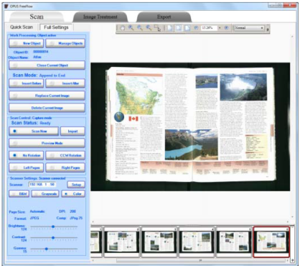

This tutorial will also be modified as procedures change. There is a plan to have **Adobe Creative Cloud** suite installed soon which will include **Photoshop** and **Bridge**. These will be added as the tutorial gets updated.

If the computer is not on please turn it on. Log in as **.\Lab** (YES, **period backslash** before Lab) with the password of **GrannyD!**

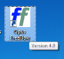Open the Opus FreeFlow software from the shortcut on the desktop   
or from the Start menu. (Start/All Programs/Image Access/Opus FreeFlow)

The Scan tab is the first of 3 tabs; Scan, Image Treatment, and Export.

The Scan screen has 4 main areas: the vertical control panel on the left-hand side is colored in Blue, the preview or current image in the center window, and thumbnail preview images located at the bottom of the screen.

The vertical control panel is used to manage objects and to operate the scanner(s).

Quick Scan menu Full Scan menu

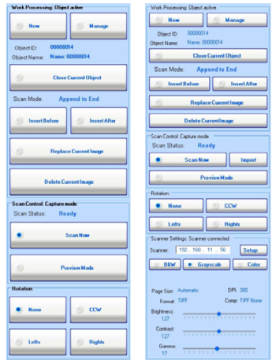  
**Quick Scan** – this hides the scanner functions and displays only standard scanning controls.   
  
**Full scan Settings** – allow for complete control of the scanning environment, including the full scanner control settings.  
  
Once **FreeFlow** has opened check in the lower left hand corner for this box with the IP address -that string of numbers which starts with 192.168.1.xxx.

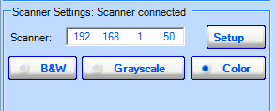

The **WideTEK25**’s IP is 192.168.1.50.

This is the proper IP address setting for the **WideTEK25**.

Change the scanner’s IP address to **192.168.1.55** *if you are using the* **Bookeye3**.

* Place an **object** on a scanner to be digitized.
* Click on **New** on the top left-hand corner of the Opus FreeFlow application.  
   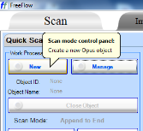  
  This will “**Create a new Opus object.**” An object is defined here as a digital copy of a physical object. Without having an open Object you will not be able to scan or import images into FreeFlow.
* Name this new object in the following window (below), it should probably be the name of the book, the title of the document, or whatever is relative to this scan. For the sake of this tutorial I will call this object **Hoornbeeck**.  
    
  You might notice that there are fields for **Object Level Metadata**, **Object Type**, **Object Name**, **Description**, and so on. If you have this data and prefer to enter it now rather than later you may choose to do so.

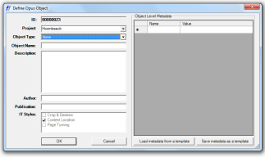   
 Values interred into this box will be exported into a CSV file (Comma Separated Values) when the derivatives are created.

At the very least, once you have named your object click **OK.**

 You may also open the Object Manager with the button to the left of New.

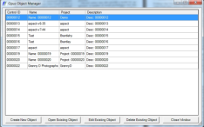FreeFlow is not designed to permanently manage your objects. They suggest to delete and purge the objects once processing has been completed.

* It is ***ALMOST*** time to make your first scan. If this scan is a book cover you may want to check that **Color** is selected in the **Scanner Settings** area of the lower left-hand corner of Opus…  
   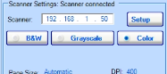  
  Notice that **Color** is indeed selected for this scan. If your scan is to be considered content pages you may opt to leave the setting on **Color**, or to change to **Black and White** (B&W), or **Greyscale** using those settings.  
    
  **To SCAN:**
* **NOW:** One may either use the **Scan->** button on the touch-screen of the WideTEK25, the **Scan Now** button within FreeFlow, use the foot-pedal, or the **Start** button on the **Bookeye3**.

This was scanned using the **WideTEK25**.   
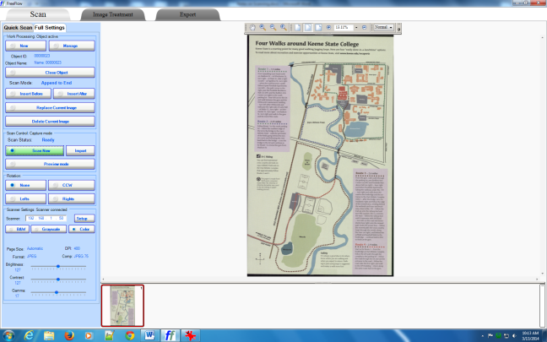

This was scanned using the **Bookeye3** after adjusting the IP address to the proper setting for this scanner (192.168.1.55).

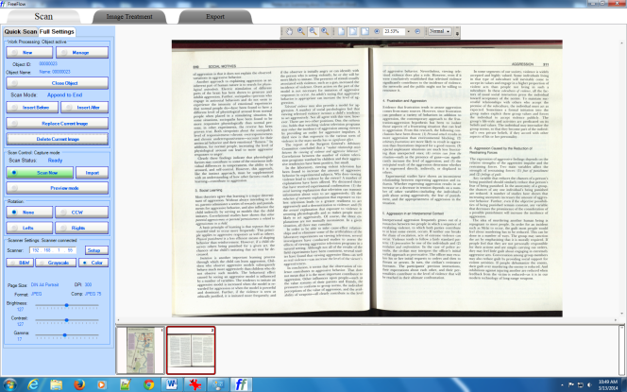

**Continue Scanning:**

* If you are scanning a book, raise the glass of the Bookeye3 scanner and turn the page(s) as desired. Move the platforms as needed to keep the surface of the glass flat and parallel with the floor as you scan through the book.  
     
  When ready use the **Scan->** button on the touch-screen of the WideTEK25, the Scan Now button within the Opus FreeFlow software, use the foot-pedal or the Start button on the Bookeye3.
* When finished scanning please power down the scanner(s). On the **Bookeye3** press and hold the red Stop button on the scanner until the voice announces “**Shutting Off**.”   
    
  To shut down the **WideTEK25** press and hold Stop on the touch-screen for 5 seconds.

This about covers the **SCANNING** aspect of this tutorial. If you’re going to continue on to Image Treatment please stay tuned.

**Image Treatment:**

After scanning images one may need to alter or edit the images. Perhaps a book’s pages are not aligned or someone’s finger was captured on the image. Whatever the case FreeFlow has its own post-scanning image manipulation application which they cleverly call Image Treatment.   
  
Click on the Image Treatment tab at the top of FreeFlow.



The application will switch from the scanning module to the Image Treatment application.

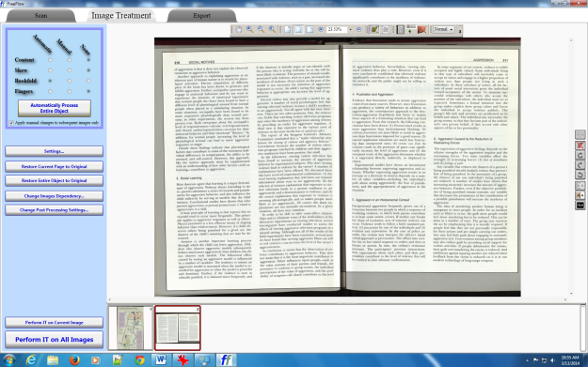

Adjustment of the image is done either by automation or manually by choosing the options in the top left-hand corner of the Image Treatment window and the overhead menu.

This is a screenshot of the overhead Image Treatment menu.



Left-click and hold this icon to grab and move the image around the viewable area.

Clicking this icon zooms in up to 1600% of the original image.

Clicking this icon reduces the image size down to 8.3% of the original.

After clicking this icon use left-mouse-button to zoom in and right-mouse-button to zoom out.



Clicking this icon creates a click-and-drag rectangle usable for checking and adjusting skew.

Clicking this icon returns to the original image size.

This icon fits the current image to the screen.



This icon fits the image to the width of the screen.

Click to reduce the size of the preview image.

Use this clickable arrow to adjust the size of the image via percentage.

This enlarges the preview image.

Use this to display a list of parts of the book. Click on the image’s thumbnail and select the corresponding part of the book.

This icon activates the manual **Content Location** and **Deskew** functions. This will allow you to adjust the size and skew of a page.  
  
This activates manual **Curvature Correction**. It allows you to adjust the curvature of the image.

Use this to open the **Finger or Artifact Removal** function.

Toggles between **Dependent** and **Independent** images.

This makes the 2 pages on the current image the same Clip size enabling the user to create the exact same image size of the selected images which eliminates “flutter” or “stutter” when viewing in a film-strip.



Use this to hide the toolbar allowing more room on the screen. To bring the toolbar back just mouse over the toolbar area and it will auto-magically reappear.

One could, for example, adjust the skew so that the text is straitened.  
  
**To adjust (Image 1):**

* Click on the first image that needs adjusting on the lower-middle tool bar with the images numbered in succession.
* Click in the box to drag and move.
* To change the content box size click on the Blue rectangles at the edges of the box and drag to desired change.
* To change the rotation and the skew use the Green rectangles at the edges of the box and drag to change.

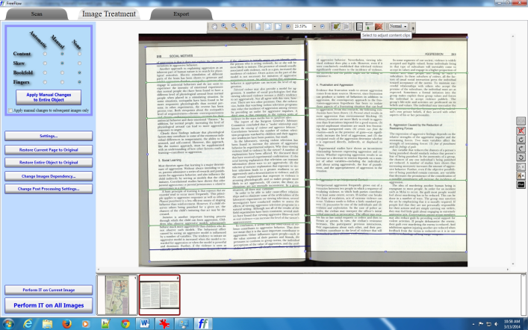

If you have multiple pages then continue onwards. If you are done with your image then please move on to the Export section of this tutorial.  
  
To adjust additional images:

* Click on the 2nd image in the lower-middle toolbar as mentioned above.
* Make any changes to skew, rotation, or size as before.

Export

* If you are done with the Image Treatment then click on the Export tab at the top of FreeFlow.
* Click on Export Images, this window should appear…

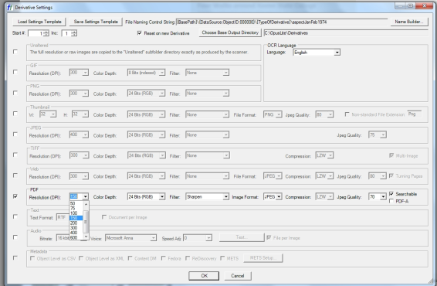

* Check off the type of image(s) that you want to be exported. There are a wide range of options such as PDF, TIFF, JPEG, etc. and many more within the row associated with the file type. For example; under TIFF and PDF there are options to make the file(s) Multi-Page and/or searchable.
* Click on “Choose BaseOutput Directory” where a popup window will prompt you for somewhere to save the finalized images. A good place would be somewhere like MyPictures or a new folder on the Desktop.
* When you are finished click on Ok. Depending on the amount of images being processed it could take quite a while for the program to finish. When it is done a message should appear under the Logs heading, for example: Batch ‘023’ has completed successfully.  
    
  That’s it for image exporting.  
  If you are done please do not forget to shut the scanner(s) off by pressing the Stop button on the scanner until it announces, boldly, that it is shutting off.